# Results Outline

1. For which models and what parameters did bursting occur?
2. What was the effect of the P2X7 component
   * on bursts
   * on peaks
3. Differences between parameter sets for each model (and each stat)
   * TB
   * Yan

differences in Burst Duration were significant across all parameter pairs for all Yan datasets and most TB datasets.

# Results Draft

Bursting behavior occurred consistently for both models for all test eL values except eL = -50. At this value, the presence of bursting was dependent on both $g_{nap}$ and model. For the TB model, bursting occurred at all values of $g_{nap}$ for eL = (-55, -60, -65) and at eL=-50 and $g_{nap}$ = 1.8 or 2.4, but not at eL = -50 for higher values of $g_{nap}$. For the Yan Model bursting did not occur for eL=-50 for any value of $g_{nap}$.

Since no bursting occurred for Yan in the eL=-50 runs, they will be excluded…

The TB model exhibited bursting behavior for more of the tested parameter space than did the Yan model.

[BzATP] values less than 10**-6 produced closely spaced spikes (tonic spikes or a burst) with a time-dependent decrease in amplitude leading to near-quiescence with small-amplitude bursts.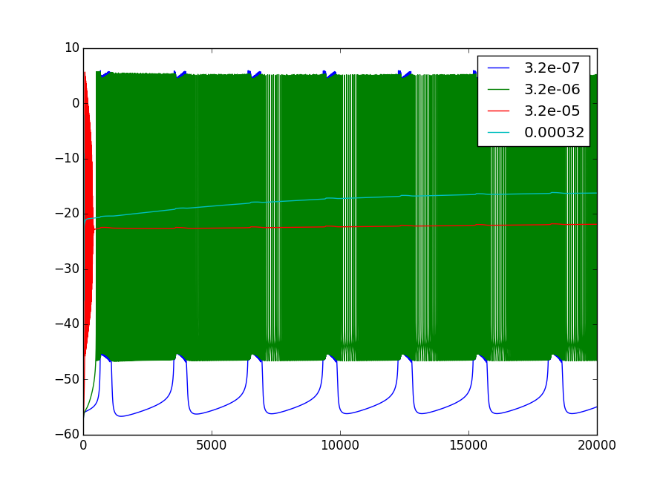

Effects of different BzATP concentrations

(needs to be redone so that 3.2e-7 is in front of 3.2e-6)

## Burst Duration, Interburst Interval, Total Cycle Time

Addition of P2X7 component biases the model towards longer bursts and shorter interburst intervals, with little difference in total cycle time between models.

With few exceptions, burst duration for the Yan model with [BzATP] = 1e-6 was significantly (p<0.001) longer than the TB model. There were four exceptions, one for eL=-60.0, $g_{nap}$ =1.8, and three for eL=-65, $g_{nap}$ = 1.8, 2.4, and 3.0. These are the three lowest $g_{nap}$ values in the tested parameter space. As eL increases, significance is lost at progressively higher values of $g_{nap}$. The same pattern of significance occurs for interburst interval, but interburst interval was smaller for the Yan model than for the TB model, except at eL=-60, $g_{nap}$=4.2. This is perhaps unsurprising since total cycle time, the time from the start of one burst to the start of the next (the sum of burst duration and interburst interval), showed no significance difference except at eL=-60 with $g_{nap}$ =4.2.

Total cycle time, the summation of interburst interval and burst duration, was not significantly different for all but one of the tested parameter combinations, eL=-60 with $g_{nap}$=4.2, and total cycle time is the summation of interburst interval and burst duration.

<Slightly zoomed in raster plots ( timeseries plots in appendix) how should I group them?>

<plots of bd, ibi, tct with parameters along the x-axis, value along the y and a line for each Model>

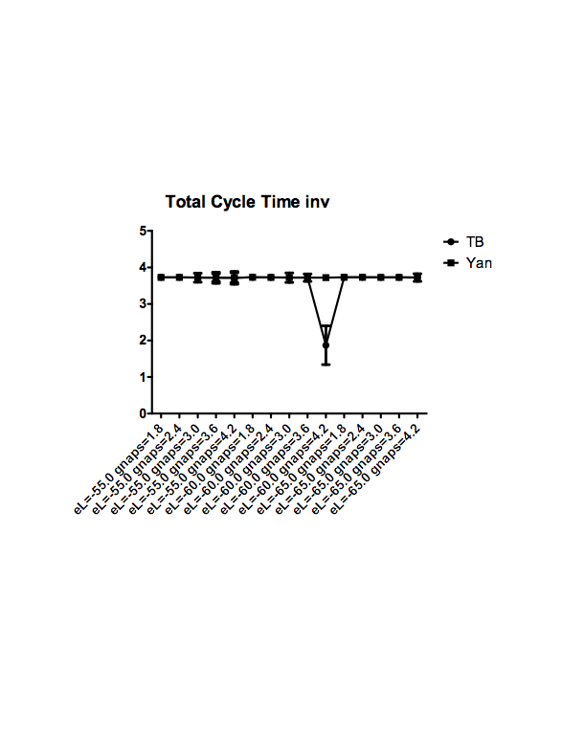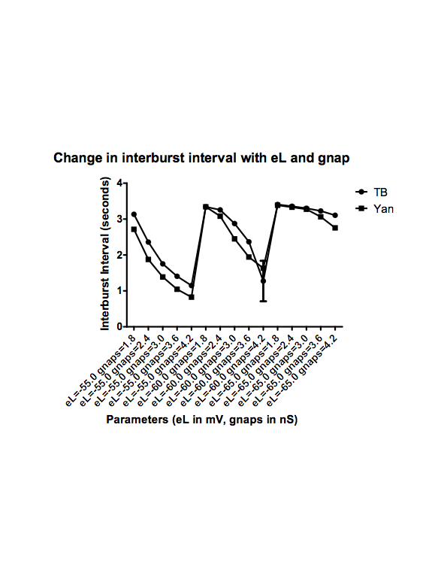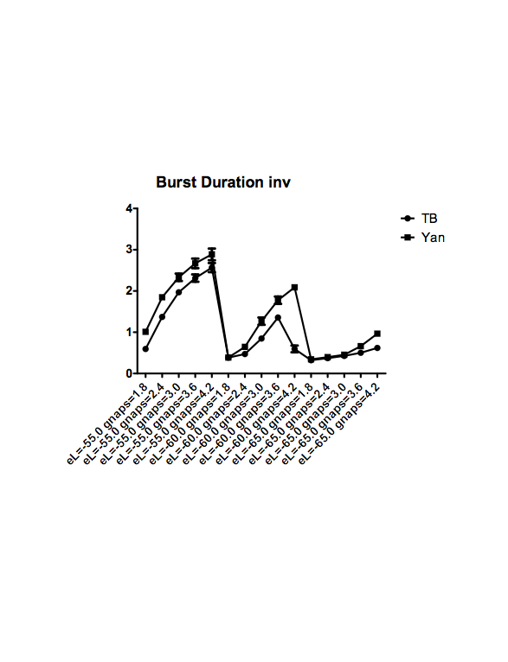

## Peaks-per-Burst, Intraburst Freq

Peaks-per-burst were significantly higher in the Yan model than in the TB Model for eL=-55, but as eL decreases we see a loss of significance at the lower values of $g_{nap}$, eL=-60 is significantly different for $g_{nap}$ = (3.0, 3.6, 4.2) but for eL=-65, only $g_{nap}$ = (3.6, 4.2) is significant. Additionally, the values for Yan are generally higher, at eL=-60, $g_naps$ = 3.0, 3.6, this flips and peaks-per-burst are significantly higher for the TB model.

For intraburst frequency, we see significantly (p < 0.001) higher values for the TB model at eL=-55 for lower values of $g_{nap}$ (1.8 and 2.4), and at eL=-60 and -65 for $g_{nap}$ = (2.4, 3.0, 3.6, 4.2). For lower values of eL, significant difference occurs at higher values of $g_{nap}$. <Note: Why is it reversed for higher eL?> We note that significant difference corresponds to $g_{nap}$ values above the critical bursting threshold for the lower values of eL.

<raster plots zoomed in to capture single burst for each set of parameters and model>

<>

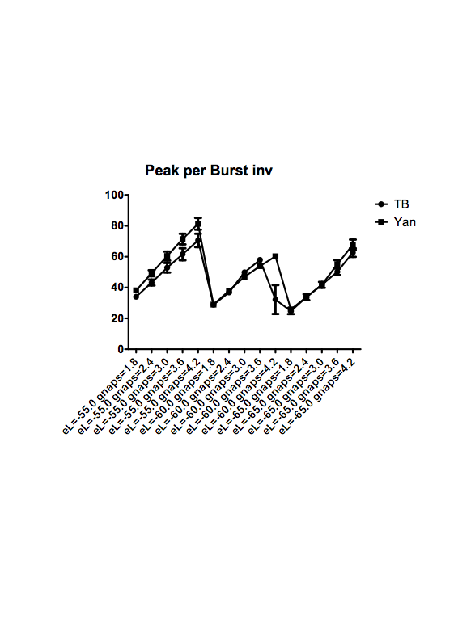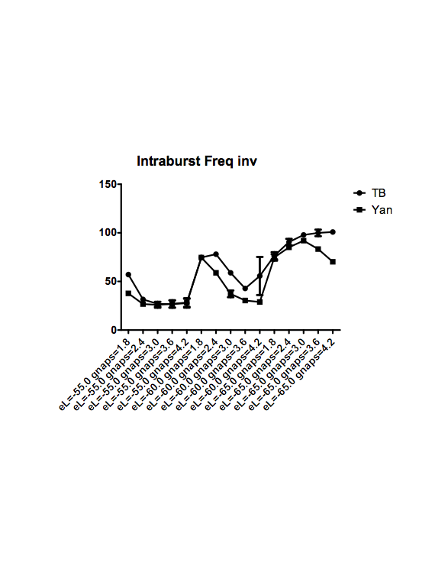

## Peak Amplitude and Peak Interval

With few exceptions (eL=-60 with gnaps=1.8 and 4.2), peak amplitude was significantly different (p < 0.001) across models for the same parameter set, while peak interval was generally not. The only significant difference in interval occurred at eL = -50 and naps = 1.8 and 2.4, as these were the values at which the Yan model exhibited no bursting.

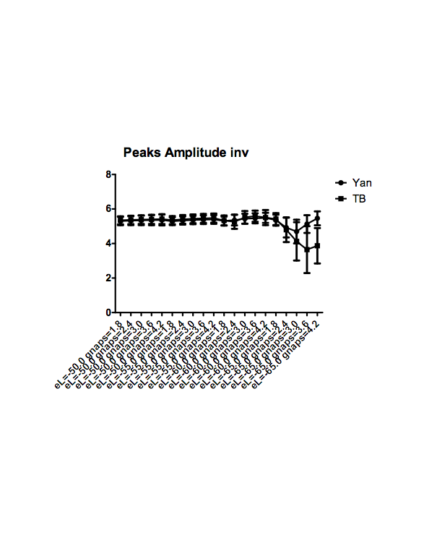

<histograms?>

## Between parameter sets for same Model

—need to talk about this with someone

Drafts

Comparing time series Figures ~\ref{fig:ts18} and ~\ref{fig:ts42}, we see that at the low end of the tested $g_{NaP}$ range (1.8 nS)...

and at the end of the range, when $g_{NaP}$ = 4.2 nS, we see ...

The Yan model is characterized by longer burst duration and more spiking along the leading edge of each burst. Bursts that are separated in the TB time series are often connected by a less-dense series of spikes in the Yan time series, which is why at eL=-50, the Yan time series show tonic spiking for all $g_{NaP}$ while the TB time series show bursting for some of the lower values of $g_{NaP}$, and why the Yan time series for eL=-60, $g_{NaP}$=4.2 does not show the dual-modes of bursting that TB does for the same parameter set.

Average total cycle time, the time from the start of one burst to the start of another, was very uniform between models for all parameter sets that exhibited bursting (Fig [~\ref{fig:hm_tct}]). The only point of significant difference was at $eL=-60 g_{nap} = 4.2$ where the value for the TB model was half that of the Yan model, due to the bi-modal bursting behavior present in the TB model but not the Yan model (Fig [~\ref{fig:ts_6042}]).

Where bursting occurs in the Yan model, burst duration for Yan increases more rapidly than TB in response to depolarization. For $eL=-55 mV$, we see model-dependent burst duration differences for all tested $g_{NaP}$ values.

Differences in burst duration between the two models does not change significantly with change in $g_{NaP}$. For Yan, bursting does not occur while $eL = -50 mV$, while bursting occurs at $eL=-50,\ g_{NaP}=1.8, 2.4$.

With one exception, interburst interval and burst duration display the same inter-model pattern of significance. The exception, at $eL=-50.0,\ g_{NaP} = 2.4$ where interburst interval is 0.62 seconds for the TB model and 0 (due to an absence of bursting) for the Yan model.

The pattern change in their values

the patterns in their values are flipped.

This is unsurprising, since Total Cycle Time, the summation of Interburst interval and burst duration, was nearly invariant across all model-parameter combinations.